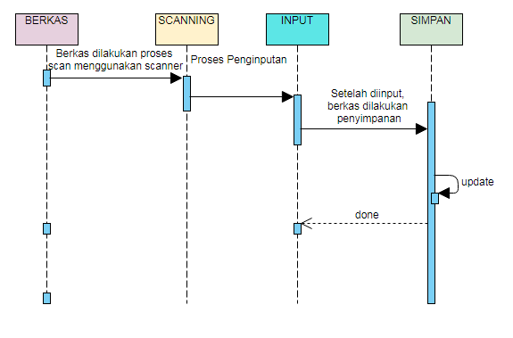**SEQUENCE DIAGRAM**